5.113: a) What really happens (according to a nosy observer on the ground) is that you slide closer to the passenger by turning to the right. b) The analysis is the same as that of Example 5.23. In this case, the friction force should be insufficient to provide the inward radial acceleration, and so 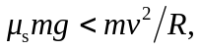 or
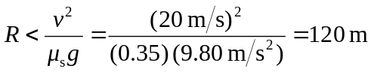
to two places. Why the passenger is not wearing a seat belt is another question.

